# Minutes for Liaison Meeting 1/30

### Slides:

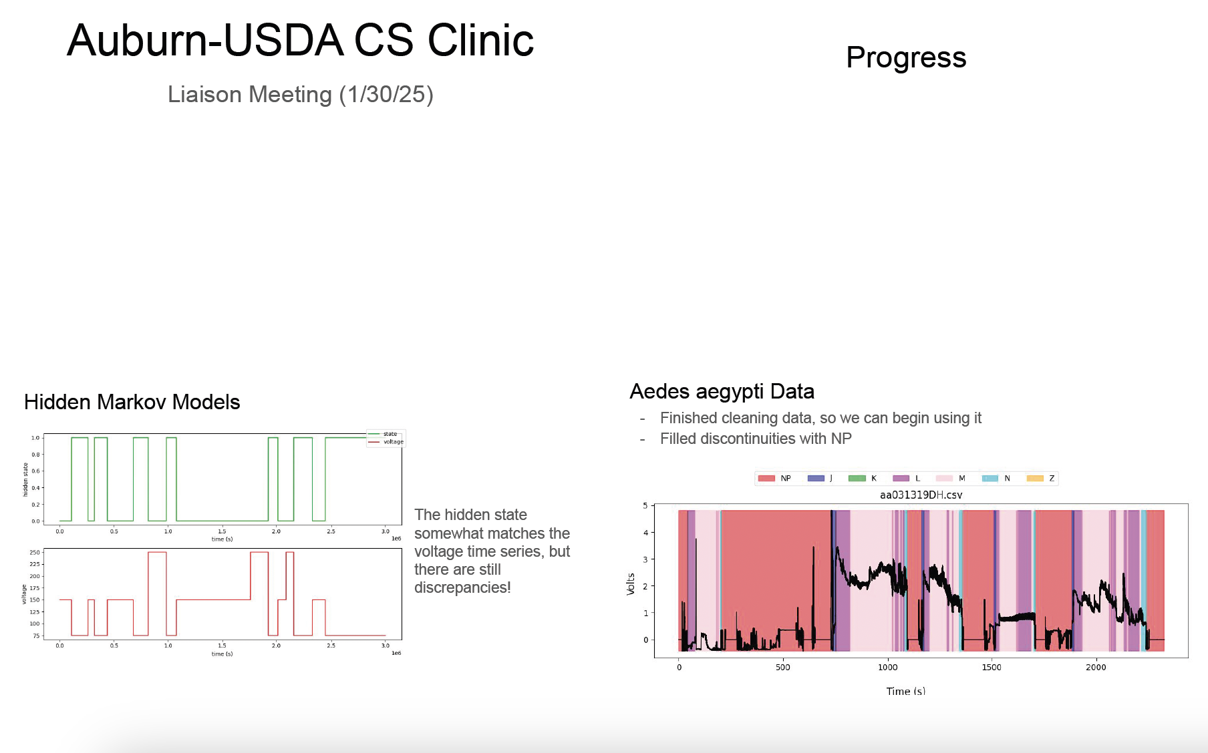

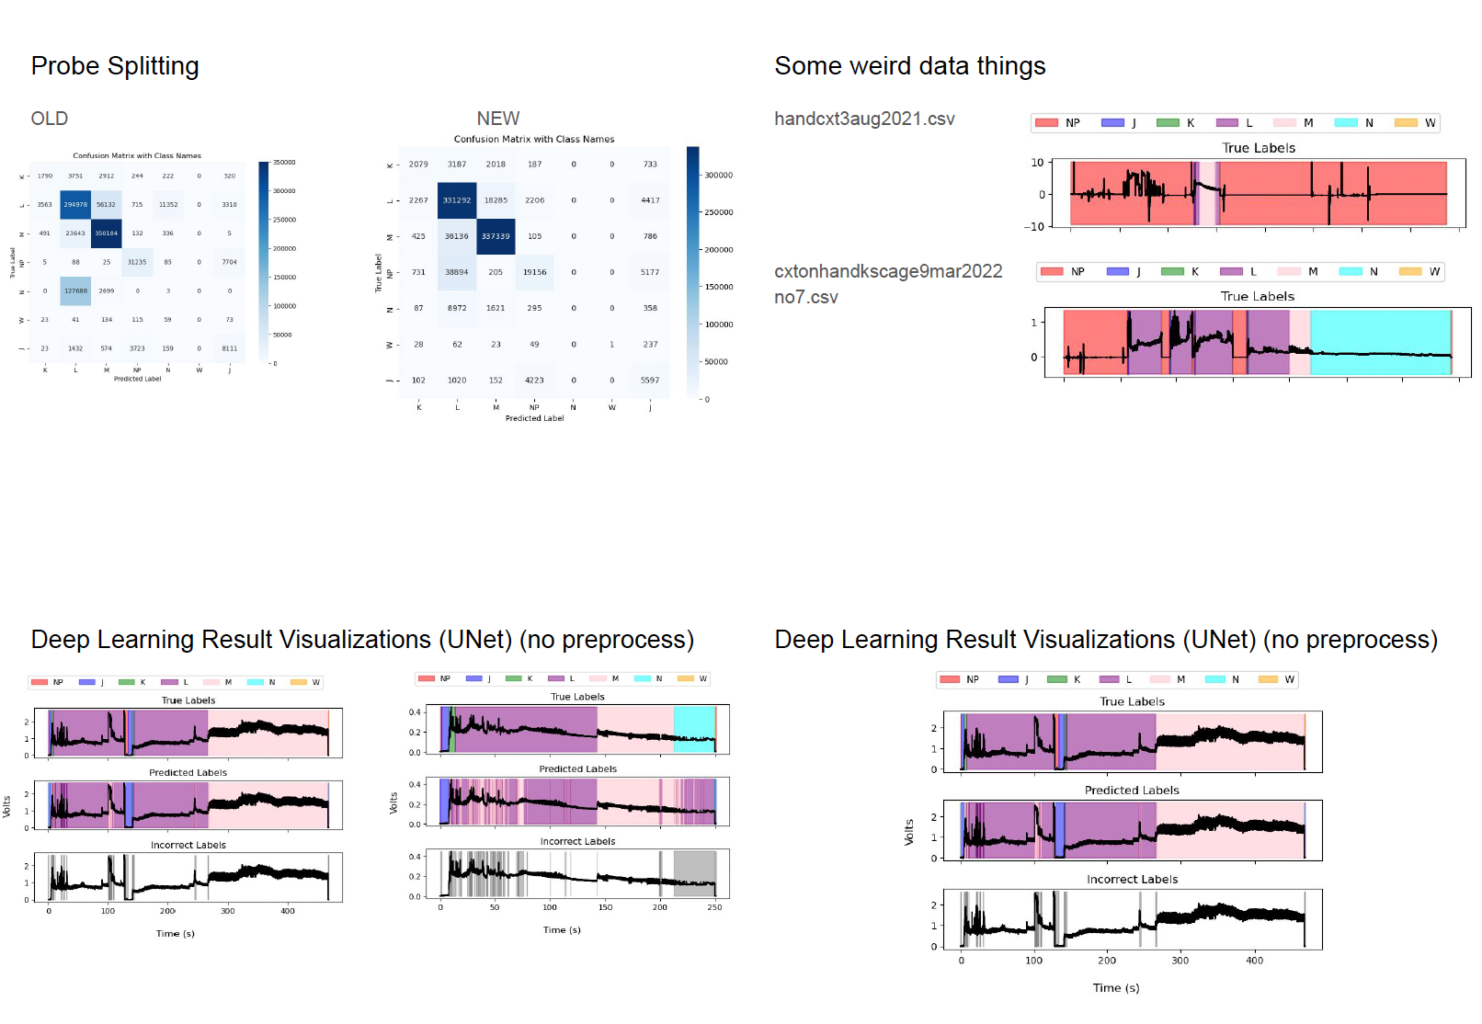

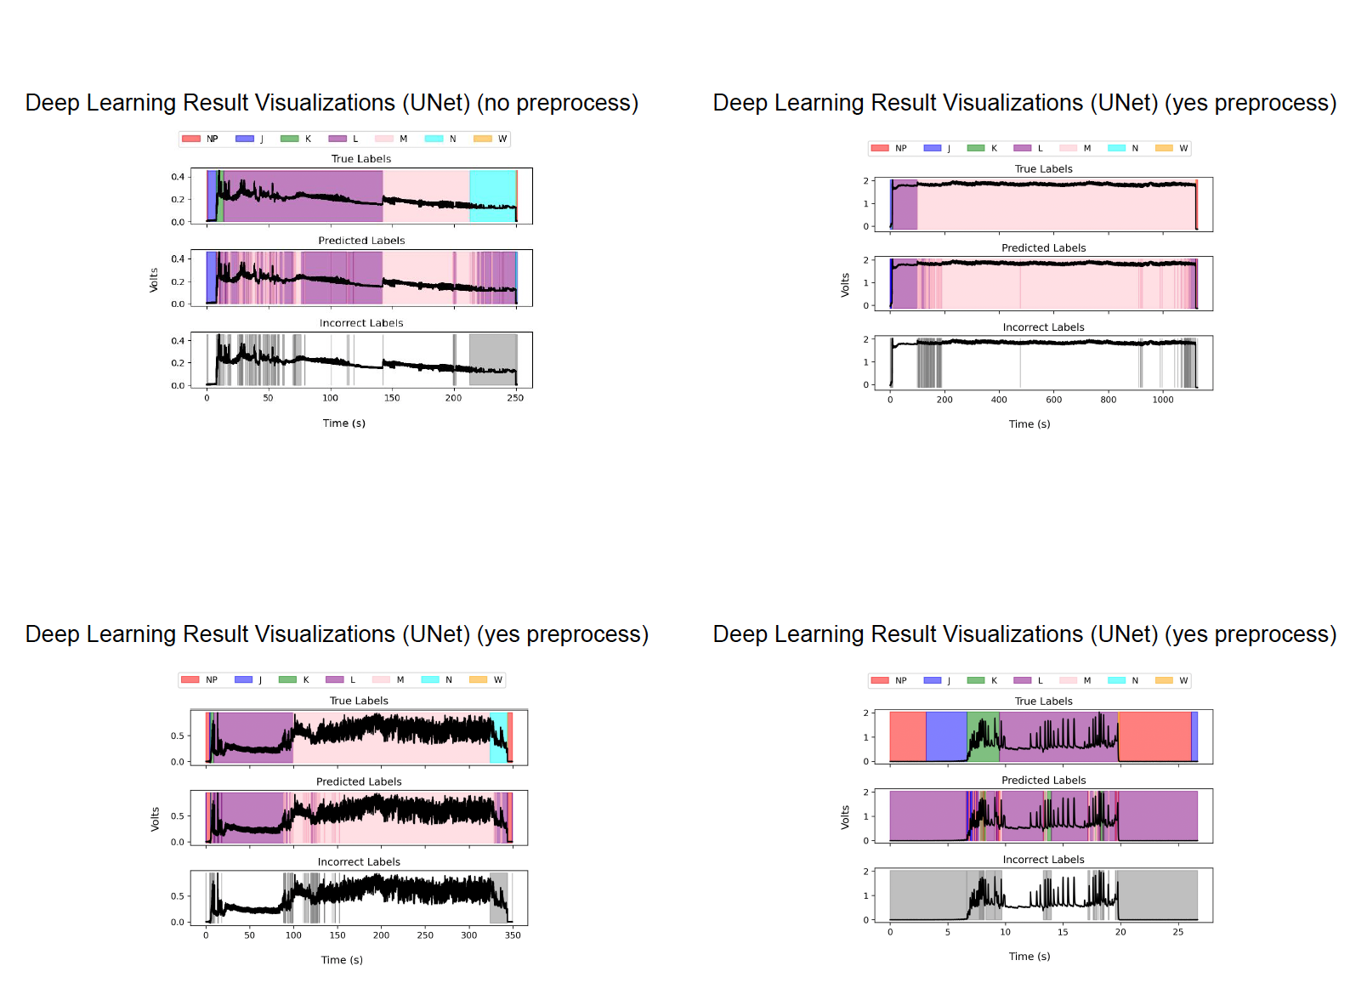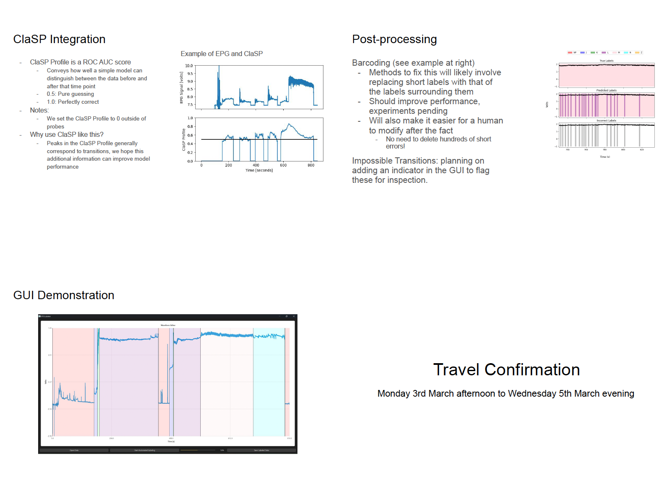

Meeting Minutes:

Zach: Hi everyone. Let’s wait for Professor Hope to join before we start the meeting.

Zach: Let’s begin with an overview of the various machine learning models we’re using and the respective updates. Devanshi will start us off.

### Machine Learning Model discussion

#### Hidden Markov Model

Devanshi:

* The Hidden Markov Model is used to identify hidden patterns within the data through “hidden states”
* Currently, I have mapped states to fluctuations in voltage in certain parametric combinations.
* As you can see there are minor discrepancies in the voltage and annotated waveform data but I’m working on optimizing this model.
* Two states yield the best results so far.
* My goal is to wrap up with this by the first week of February.
* By then I’m hoping that this model will have been reasonably trained and optimized, applied to the dataset, and documented.

Aedes Aegypti Data

Lillian:

* I have finished cleaning the data, so we can begin using it.
* This has involved filling in discontinuities with NP label for waveforms

Probe Splitting

Milo:

* Confusion Matrix with class names have been improved in terms of prediction accuracy

#### 

#### Deep Learning Result Visualizations (UNet)

Milo:

* Comparison between without preprocessing and with preprocessing
* Discussion about how preprocessing has improved the UNet deep learning result visualizations and what preprocessing looks like

#### 

#### ClaSP Integration

Zach:

* ClaSP Profile is a ROC AUC score.
  + Measures how well a simple model distinguishes between data before and after a given time point.
  + Score Interpretation:
    - 0.5: Pure guessing
    - 1.0: Perfectly correct
* ClaSP Profile is set to 0 outside of probes.
* Peaks in the ClaSP Profile generally correspond to transitions, which we hope will improve model performance.

##### Barcoding (Error Correction Method)

* Fixing barcoding errors involves replacing short labels with those of the surrounding labels.
* Expected improvements:
  + Enhanced model performance (experiments pending).
  + Easier manual modification post-processing.
  + Eliminates the need to delete numerous short errors.

Impossible Transitions:

* Planning to add an indicator in the GUI to flag these for inspection

### GUI Demonstration Feedback:

* Adjust the number of gridlines, reposition them as reference points, and allow toggling.
* Ensure the program prevents unintentional overwriting of raw/original files (i.e., automatic 'Save As').
* Implement an undo functionality.
* Allow customization of line/background colors (as part of user settings).
* Display both pre- and post-signals in the window; consider a panel with all loaded data for toggling visibility.
* Ensure appropriate resolution for data capture and publication.
* Improve zoom capabilities on both the x and y axes.
* Enable toggling of label color visibility.
* Prototype hardware will have only one output (no pre-rectified data); determine if both modern and legacy data should be accommodated.

Dr Backus: How will this program work in the context of the previous work done on this clinic project last year? And in partnership with the engineering clinic this year. How will we use the programs — independently?

Zach: Mehrezat do you want to take this question or should I?

Mehrezat: I can take this one. So we’re reasonably sure that these programs and we’ve made sure to coordinate with the engineering clinic to understand and keep ourselves posted to their project progress so we’re making sure our work does not contradict each others’.

### Site Visit Discussion

Dr. Backus: How are we going to make the recordings? The only instrument available is an analog version.

* Live Recordings:
  + We can wire up bugs, but if that doesn’t work, we may need to reverse the order of dates.
  + Do you need live recordings?

Zach: We already have data to work with for testing. This trip is more about working with you directly and getting fast recordings over a day or two. Live recordings are not strictly necessary.

Dr. Backus: I’m concerned about the lack of live recordings. Without them, seeing the equipment might not be as valuable.

Dr. Reif: The team should create a schedule outlining anticipated activities to optimize planning for the day. Even if teams were reversed, the program might not work as well on sharpshooter data compared to mosquito data. Live demos are not currently happening, but we should ensure comfort working with the program in real time.

Zach: We’ll have a prototype ready before the visit. Can we start the HMC bureaucracy process for scheduling our trip?

Dr. Backus: The packing plant trip is highly recommended—it's amazing to see practical applications of your work.

* We can schedule this for Wednesday morning instead of the afternoon.
* We aim to have dinner on Monday night.
* Hotel details are still being determined; we will update you ASAP.
* The hotel will be a 15-20 minute drive from the research station, so coordinating the night before would be ideal.
* Schedule Overview:
  + Tuesday: Main day for work.
  + Wednesday morning: Packing lab visit.
  + Return to Claremont by 4-5 PM on Wednesday.
  + The schedule is flexible based on team preferences.

Zach: Sounds good. We’ll get started on the planning.

Mehrezat: We’ve discussed the plans.

Dr. Backus: Four hours are allocated for Wednesday morning.

Dr. Cooper: Please send me an updated email with the changed dates, Dr. Backus.

Dr. Backus: The travel schedule remains unaffected; we just need to finalize hotel details.

### Publication Discussion

Zach: We intended to discuss the publication, but we can push it to the next meeting. An example publication was shared for review.

Dr. Backus: Great meeting, everyone! Pleased with the progress.